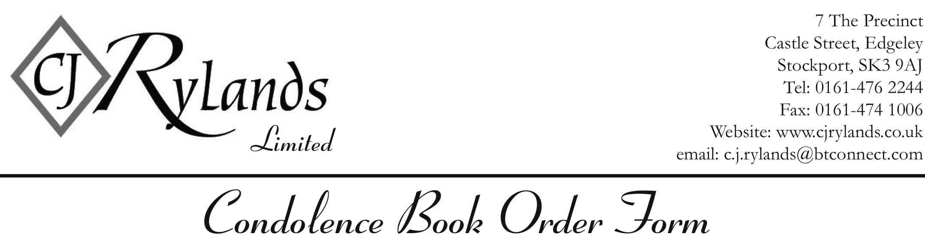
PLEASE EMAIL THIS COMPLETED FORM TO: c.j.rylands@btconnect.com
OR FAX TO 0161 474 1006
Heading Fondest Memories Of (Tick If Required)

Alternative Heading

Name of Deceased

Date of Death

Age At Time Of Death

Epitaph Just as you were you will always be, Treasured forever in our memories (Tick if req’d)

Alternative Brief Epitaph

Photograph Required? YES NO
(please email to c.j.rylands@btconnect.com with the deceased’s name as reference)

Method of Postage 1st Class Next Day Delivery *

*(Guaranteed before 1pm the very next day, except weekends/bank holidays)
– Royal Mail Terms & Conditions Apply

Design Required
Traditional Black Traditional White Premium Black
28 Pages / 112 Messages 28 Pages / 112 Messages 304 Pages / 1216 Messages

Name & Address For
Return Of Book(s)

Postcode

Contact Tel. No

Email Address (optional)

